Go Green today, Get Greener Life Tomorrow
Human has pride of being God’s most beautiful creation but this beauty is the soul companion of nature. It’s our collective responsibility to look after Mother Nature. To live up to the above said words DAV Public School, East of Loni Road celebrated Vanmahotsav week from 19th August to 23rd August 2019. The whole school family including students and staff members participated lively in the various activities organized throughout the week.
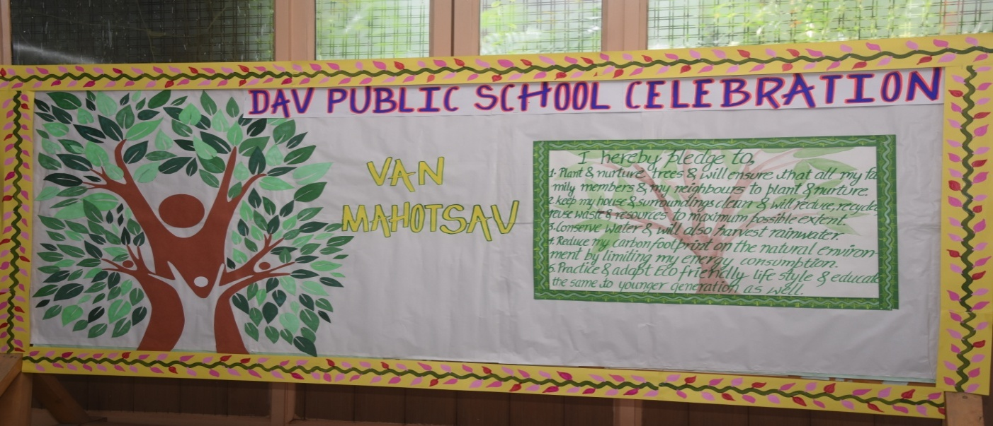
The week commenced with Eco pledge taken by all the students and teachers to save and plant more trees during special assembly on 19th August, 2019. “Go Green, Save Trees” badges were donned to teachers and Principal Ma’am by students.

In order to sensitize students about the need to preserve environment Eco- Rally and Outdoor Plantation were held on 20th August, 2019. Students of class 9 and 10 participated actively in both the activities. They went to nearby areas along the teachers with banners and posters. Plants like Neem, Aloe Vera, Basil, Hibiscus etc, were planted.

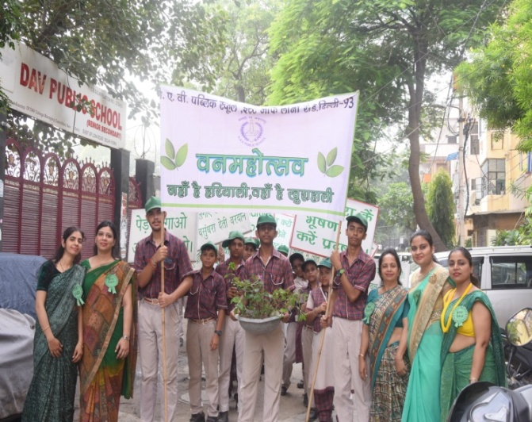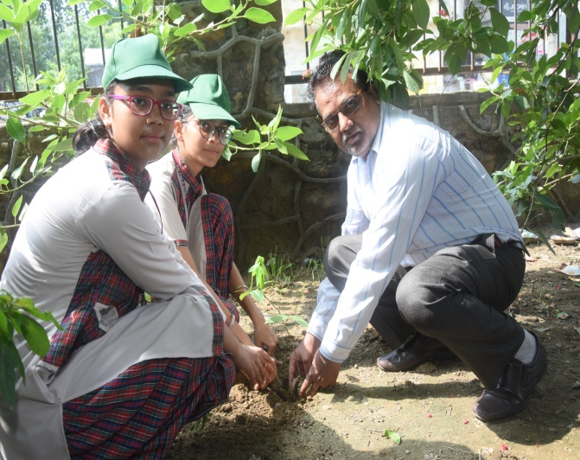
A total of ____ saplings were planted. Students raised slogans which created a great stir in nearby people regarding environment conservation. Students of class –IV recited poems on importance of trees and gave a special place to trees in their heart through their innocent words.
The celebration on 21st August 2019 turned out to be a special one as this day witnessed plantation by our prominent School Manager Mr. Nanak Chand, Chief guest Mr. R. K Tiwari, Principal DAV Public School, Daryaganj, Delhi and our Principal Mr. Sameeksha Sharma.
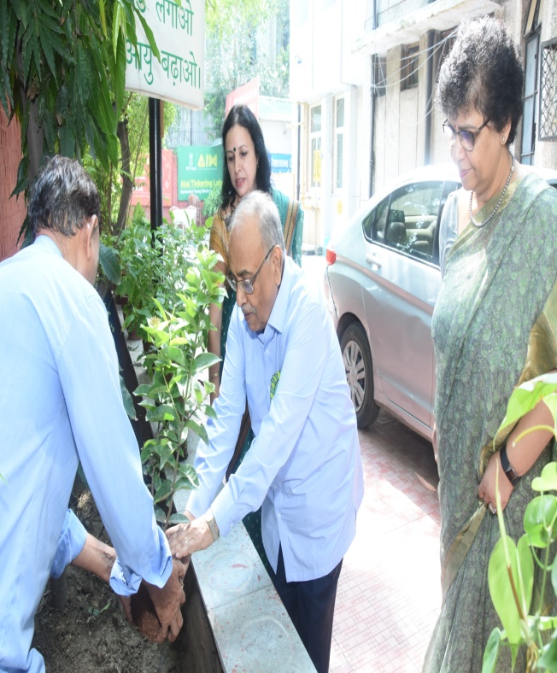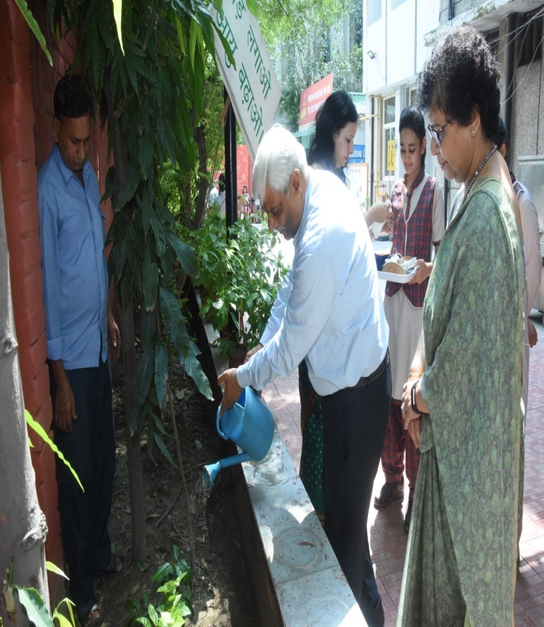

Students of Pre- School and Pre- Primary got into colour green through Leaf Printing activity whereas students satisfied their creative instincts through ear bud painting activity.
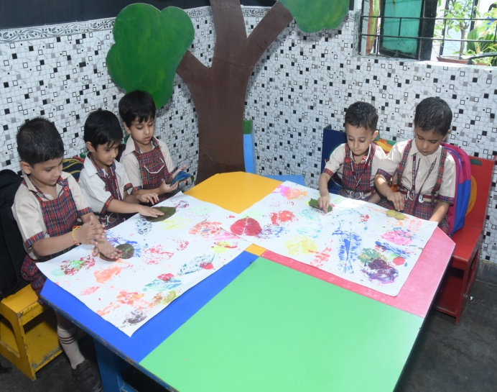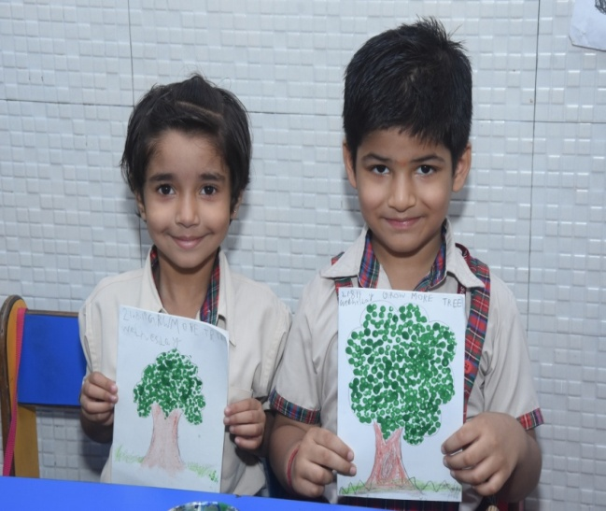

22nd August 2019 came with pleasing astonishment for all the students in the form of manifold activities. Students of Class – 1 and 2 tied Rakhi to trees and created a special emotional bond forever.
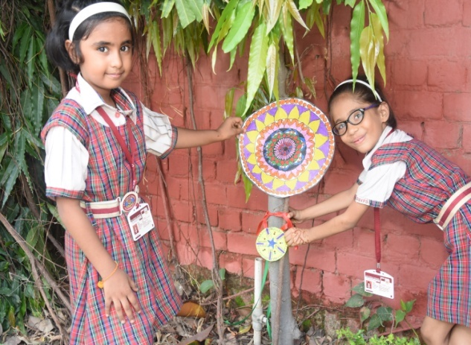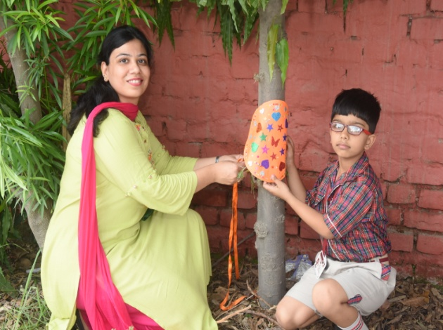
Eco fashion show became talk of the town when students of Class– 3 came up with dresses made up of newspaper during ramp walk. Their little steps gave message to reduce , reuse and recycle. Students from class 4 to 12 had brought saplings and then planted them in the school premises with the help of their teachers and supporting staff members during indoor plantation activity.
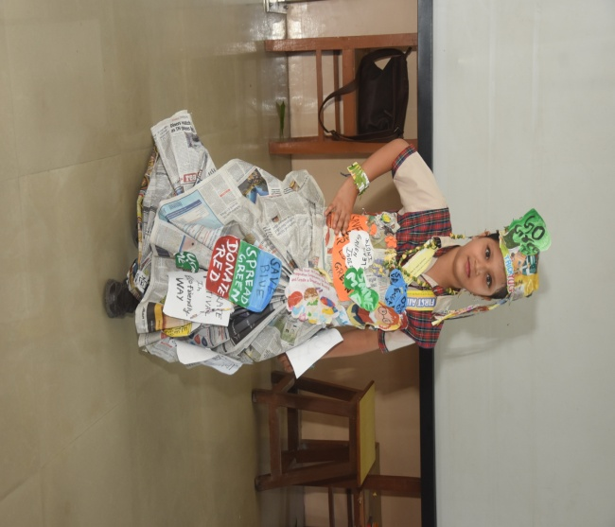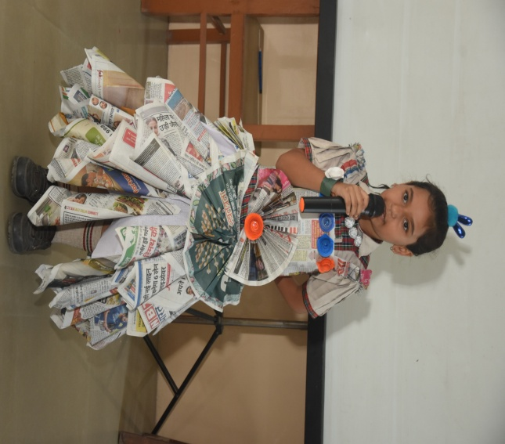
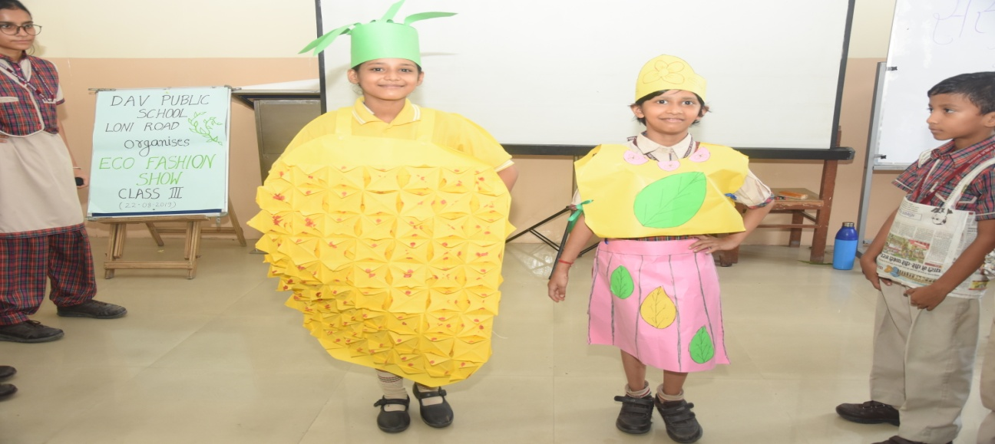

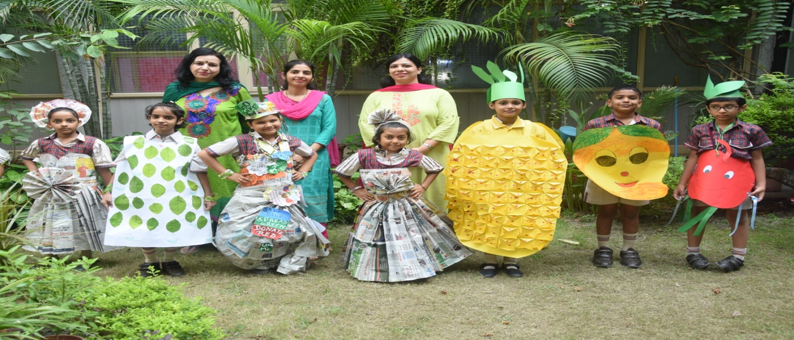
On 23rd August 2019 “Go Green” temperament was visible all around in the school. The happiness and satisfaction of being this close to nature in the past four days changed the air of school. To take this spirit to another level, students of class 4th to 12th did activities based on 'Kabaad se jugaad’. They used waste material like old egg trays, plastic bottles etc. to make useful items.These brilliant minds made working model of AC , Refrigerator and vacuum cleaner out of the waste material .
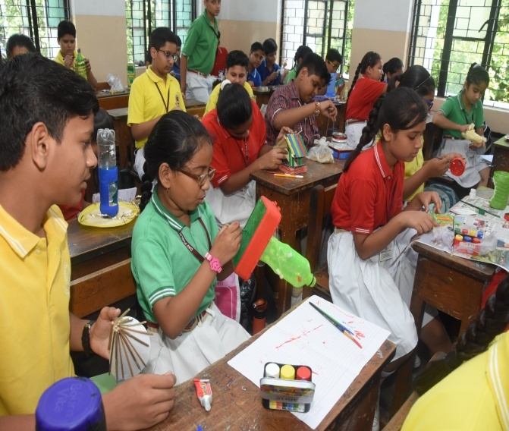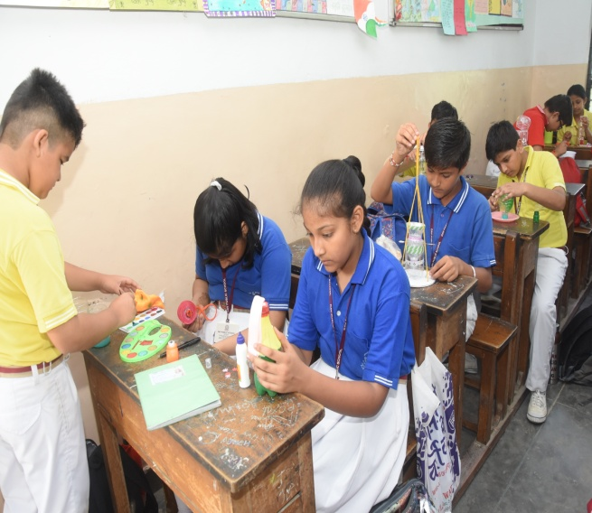
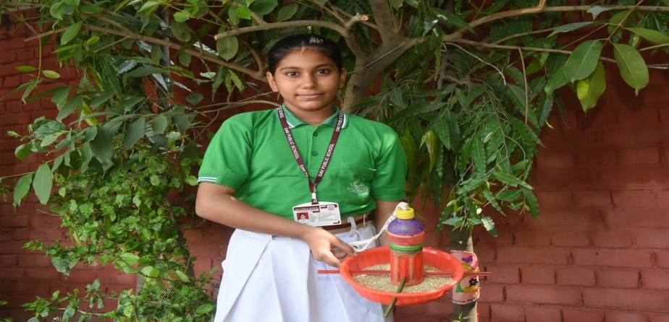
The whole week was celebrated with great zeal and fervor due to which it turned out to be a grand success. A harmonious participation of students and staff members created awareness about the green cover around us and strengthened the bond between plant and humans.
